**Experiment: Arduino-Based Smoke Sensor Detection**

**1. Aim**

To design and implement a smoke detection system using an **Arduino** and an **MQ-2/MQ-135 smoke sensor**, which triggers an alert when smoke levels exceed a predefined threshold.

**2. Components Required**

* **Arduino Uno** (or any compatible board)
* **MQ-2/MQ-135 Smoke Sensor**
* **Buzzer**
* **LED**
* **Resistors (220Ω, 1kΩ)**
* **Jumper Wires**
* **Breadboard**
* **Power Supply (5V from Arduino)**

**3. Background Theory**

The **MQ-2/MQ-135 smoke sensor** is widely used for gas detection in home safety systems. It can detect gases like **LPG, methane, butane, alcohol, smoke, and carbon monoxide**. The sensor has a **heater element** that ionizes gases, changing the resistance of the sensor. This change is converted into an **analog voltage**, which can be read by the Arduino.

* **Working Principle:**
  + The sensor outputs an **analog voltage** proportional to the smoke concentration.
  + The Arduino processes this voltage and triggers an alert if it crosses the threshold.
  + A **buzzer and LED** provide a visual and audible alert.

**4. Circuit Diagram**

Connections:

1. **MQ-2/MQ-135 Sensor**
   * VCC → 5V (Arduino)
   * GND → GND (Arduino)
   * A0 → A0 (Arduino)
   * D0 → Digital Pin (Optional, if using digital output)
2. **Buzzer**
   * Positive → Pin 9 (Arduino)
   * Negative → GND
3. **LED**
   * Positive → Pin 8 (Arduino)
   * Negative → GND (via a 220Ω resistor)

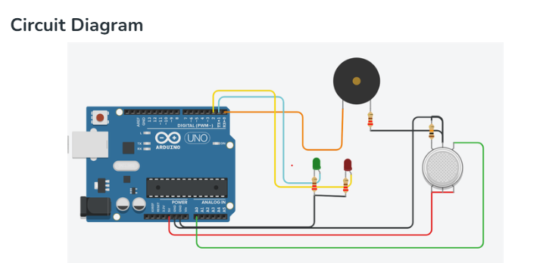

**5. Arduino Code**

cpp

CopyEdit

const int smokeSensorPin = A0; // Analog input for MQ-2

const int buzzerPin = 9; // Buzzer pin

const int ledPin = 8; // LED pin

const int threshold = 300; // Smoke threshold value

void setup() {

pinMode(buzzerPin, OUTPUT);

pinMode(ledPin, OUTPUT);

Serial.begin(9600); // Start Serial Monitor

}

void loop() {

int sensorValue = analogRead(smokeSensorPin); // Read sensor value

Serial.print("Smoke Level: ");

Serial.println(sensorValue); // Display value in serial monitor

if (sensorValue > threshold) { // If smoke detected

digitalWrite(buzzerPin, HIGH);

digitalWrite(ledPin, HIGH);

Serial.println("WARNING: Smoke Detected!");

} else {

digitalWrite(buzzerPin, LOW);

digitalWrite(ledPin, LOW);

}

delay(1000); // Wait 1 second before next reading

}

**6. Steps**

1. **Set up the hardware:** Connect the **MQ-2/MQ-135 sensor, buzzer, and LED** to the Arduino as per the circuit diagram.
2. **Upload the Code:** Use **Arduino IDE** to upload the above code.
3. **Monitor the Serial Output:** Open the **Serial Monitor** (9600 baud rate) to check real-time smoke levels.
4. **Test with Smoke:** Introduce **smoke (e.g., from a matchstick)** near the sensor.
5. **Observe the Response:** If the smoke level **exceeds the threshold**, the **buzzer and LED turn ON**.
6. **Verify Alert Deactivation:** Once the smoke clears, the **buzzer and LED should turn OFF**.

**7. Result**

The smoke detection system successfully detects smoke and triggers an **audible and visual alarm**. The sensor readings are displayed on the **Serial Monitor**, and the system functions as expected when exposed to smoke.